### SKIN DISEASES IDENTIFICATION USING IMAGE ANALYSIS

### Using Deep learning techniques-convolution neural network

### Developed by: Akula Prudvitha,Nagula Susmitha,Pittala Aravind,Chevva Srinad

**Smart Bridge-Remote Summer Internship Program**

**1.INTRODUCTION**

Skin diseases are more common than other diseases. Skin diseases may be caused by fungal infection, bacteria, allergy, or viruses, etc. A skin disease may change texture or colour of the skin. In general, skin diseases are chronic, infectious and sometimes may develop into skin cancer. Therefore, skin diseases must be diagnosed early to reduce their development and spread. The diagnosis and treatment of a skin disease takes longer time and causes financial and physical cost to the patient.

In general, most of the common people do not know the type and stage of a skin disease. Some of the skin diseases show symptoms several months later, causing the disease to develop and grow further. This is due to the lack of medical knowledge in the public. Sometimes, a dermatologist (skin specialist doctor) may also find it difficult to diagnose the skin disease and may require expensive laboratory tests to correctly identify the type and stage of the skin disease. The advancement of lasers and photonics based medical technology has made it possible to diagnose the skin diseases much more quickly and accurately. But the cost of such diagnosis is still limited and very expensive. Therefore, we propose an image processing-based approach to diagnose the skin diseases. This method takes the digital image of disease effect skin area then use image analysis to identify the type of disease. Our proposed approach is simple, fast and does not require expensive equipment's other than a camera and a computer.

**1.1 Overview**

Medical images have made a great contribution to early diagnosis. In this study, a new strategy is presented for analysing medical images of skin with melanoma and nevus to model, classify and identify lesions on the skin. Machine learning applied to the data generated by first and second order statistics features, Gray Level Co-occurrence Matrix (GLCM), key points and colour channel information—Red, Green, Blue and grayscale images of the skin were used to characterize decisive information for the classification of the images. This work proposes a strategy for the analysis of skin images, aiming to choose the best mathematical classifier model, for the identification of melanoma, with the objective of assisting the dermatologist in the identification of melanomas, especially towards an early diagnosis.

**1.2 Purpose**

Our aim from the project is to make use of pandas, matplotlib, & seaborn libraries from python to extract the libraries for machine learning for the loan prediction.

Secondly, to learn how to hyper tune the parameters using grid search cross validation for the Naïve Bayes machine learning algorithm.

And in the end, to predict whether the loan applicant can replay the loan or not using voting ensemble techniques of combining the predictions from multiple machine learning algorithms and withdrawing the conclusions

**2. LITERATURE SURVEY**

Several researchers have proposed image processing-based techniques to detect the type of skin diseases.

Here we briefly review some of the techniques as reported in the literature.

In [1], a system is proposed for the dissection of skin diseases using colour images without the need for doctor intervention. The system consists of two stages, the first the detection of the infected skin by uses colour image processing techniques, k-means clustering and colour gradient techniques to identify the diseased skin and the second the classification of the disease type using artificial neural networks. The system was tested on six types of skin diseases with average accuracy of first stage 95.99% and the second stage 94.016%.

In the method of [2], extraction of image features is the first step in detection of skin diseases. In this method, the greater number of features extracted from the image, better the accuracy of system.

The author of [2] applied the method to nine types of skin diseases with accuracy up to 90%.

Melanoma is type of skin cancer that can cause death, if not diagnose and treat in the early stages. The author of [3], focused on the study of various segmentation techniques that could be applied to detect melanoma using image processing. Segmentation process is described that falls on the infected spot boundaries to extract more features.

The work of [4] proposed the development of a Melanoma diagnosis tool for dark skin using specialized algorithm databases including images from a variety of Melanoma resources. Similarly, [5] discussed classification of skin diseases such as Melanoma, Basal cell carcinoma (BCC), Nevus and Seborrheic keratosis (SK) by using the technique support vector machine (SVM). It yields the best accuracy from a range of other techniques.

On the other hand, the spread of chronic skin diseases in different regions may lead to severe consequences. Therefore, [6] proposed a computer system that automatically detects eczema and determines its severity. The system consists of three

stages, the first effective segmentation by detecting the skin, the second extract a set of features, namely colour, texture, borders and third determine the severity of eczema using Support Vector Machine (SVM).

In [7], a new approach is proposed to detect skin diseases, which combines

computer vision with machine learning. The role of computer vision is to extract the features from the image while the machine learning is used to detect skin diseases. The system was tested on six types of skin diseases with accurately 95%.

**2.1 Existing Problem**

Now a day’s people are suffering from skin diseases, More than 125 million people suffering from Psoriasis also skin cancer rate is rapidly increasing over last few decades specially Melanoma is most diversifying skin cancer. If skin diseases are not treated at earlier stage, then it may lead to complications in the body including spreading of the infection from one individual to the other. The skin diseases can be prevented by investigating the infected region at an early stage. The characteristic of the skin images are diversified, so that it is challenging job to devise an efficient and robust algorithm for automatic detection of the skin disease and its severity. Skin tone and skin colour plays an important role in skin disease detection.

**2.2 Proposed Solution**

To overcome the above problem we are building a model which is used for the prevention and early detection of skin cancer, psoriasis. application is built where a person can upload an image from UI ,then image will be sent the trained model. The model analyse the image and detect the skin disease that person had. Our system will use a Convolution neural network to train the images of skin diseases.

**3. THEORETICALANALYSIS**

The present study investigates the best strategy for aiding in the diagnosis of the presence or absence of melanoma through skin imaging. In the proposed strategy, what differentiates it from other methods of texture analysis is the inclusion of RGB components, adding texture information to the key points.

The developed strategy involves the following steps:

1.Random selection of a set of images with melanoma

2.Generation of key points containing:

a. first order statistics information;

b. second order statistics parameters

c. RGB component information.

3.Extraction of characteristics from all training images. 4.Classification phase with the modelling using the training database.

5.Application of the selected model to a test image database.

6.Result of the model applied to the test database.

In addition, the algorithm used to read the key points does not depend on the image position, when capturing information in the region of interest—ROI.

The block diagram in Figure3shows the proposed strategy.

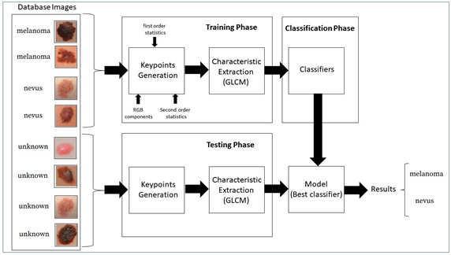

**Figure 3. Block Diagram of the proposed strategy.**

All data sets used are available in the Skin Lesion Analysis Towards Melanoma-International Skin Imaging Collaboration (ISIC) 2019 [25].

The data base was formed by 2000jpeg skin images, selected at random. The learning process was performed on 75% of the database, as in this research, 10 samples were used per image, the learning process analysed a total of 15,000 samples.

In the testing process, the remaining 25% of the images in the database were used, making a total of 5000 samples in the testing phase. Each sample had a dimension of 6 pixels × 6pixels.

To increase the efficiency in extracting characteristics for differentiation of the tissues, it was necessary to add parameters as first and second order statistics into key points, such as—mean, variance, kurtosis, skewness, contrast, correlation, entropy, energy, maximum and minimum value, as well as RGB components.

After extracting the characteristics of the images, modelling was performed through training the database, using the best-known classifiers and their variations, as found in the academic literature:

* Stochastic Gradient Classifier. The basic idea of this classifier method is straight forward—iteratively adjust the parameters θ in the direction where the gradient of the cost function is large and negative. In this way, the training procedure ensures the parameters flow towards a local minimum of the cost function.
* Naïve Bayes Classifier. A Naive Bayes classifier is a simple probabilistic classifier based on applying Bayes’ theorem (from Bayesian statistics) with strong (naive)independence assumptions. This classifier is among those common learning methods grouped by similarities which makes use of Bayes’ theorem of probability to build ML models, especially those related to disease prediction and document classification.
* Decision Tree Classifier. A decision tree is a decision support tool that uses a tree-like graph and its possible results. It is a way to display the algorithm.
* Random Forest Classifier. Random forests are an ensemble learning method for classification, regression and other tasks, that operate by constructing a multitude of decision trees at training time.
* As a result, the classes (classification) or average forecast(regression) of these individually generated trees are grouped. This method aims at averaging many approximately unbiased but noisy trees too be train low variances results. Is a collection of decision stress, which, together, forms a forest.
* KNN Classifier. Classification is achieved by identifying the nearest neighbours to a query example and using those neighbours to determine the class of the query.
* Support Vector Machine Classifier. The objective of the SVM classifier is to find the hyper plane that separates the points of classes *C*1and*C*2 with a maximum margin, linearly penalizing points within the margin through a regularization parameter selected by the user. Support vector machines bring a new option to the pattern recognition problem with clear connections in statistical learning theory. They differ radically from other methods, for example, neural networks—the training of an SVM always finds a global minimum and its simple geometric interpretation provides much scope for deeper investigations.
* Model Logistic Regression Classifier. Logistic regression classifies by using the log-ratios between the probability of groups given the data. For the groups *g*1 and*g*2:

P(G = g1 X =x)/P(G = g2.X =x)= β0=+x βx=0

The decision boundary is the value where the probability of the group given the data is equal. To find it, the likely-hood function of β is maximized:

L(β)= logPgi(xβ).

**3.1 Block Diagram**

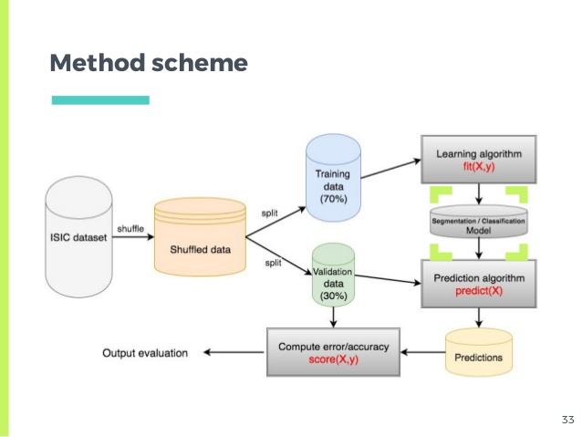

**3.2 Software Designing**

* Jupyter Notebook Environment
* Spyder Ide
* Machine Learning Algorithms
* Python (pandas, numpy, matplotlib, seaborn,sklearn)
* HTML
* Flask

We developed this loan status prediction by using the Python language which is a interpreted and high level programming language and usng the Machine Learning algorithms.

for coding we used the Jupyter Notebook environment of the Anaconda distributions and the Spyder, it is an integrated scientiﬁc programming in the python language.

For creating an user interface for the prediction we used the Flask. It is a micro web framework written in Python. It is classiﬁed as a microframework because it does not require particular tools or libraries. It has no database abstraction layer, form validation, or any other components where pre-existing third-party libraries provide common functions, and a scripting language to create a webpage is HTML by creating the templates to use in the functions of the Flask and HTML.

**4. EXPERIMENTAL INVESTIGATION**

**4.1 Description of The Dataset**

We compiled our dataset by collecting images from different websites specific to skin diseases. The database has 80 images of every disease ( 530 Melanoma images, 530 Acne images and 530 Psoriasis images, 530 Rosacea images , 530 Vitiligo images).

Fig 1 shows some of the sample images from our dataset.

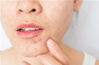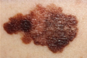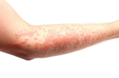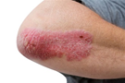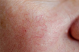

**Acne Melanoma Vitiligo Psoriasis Rosacea**

**Fig. 1. The first image is eczema, the second Melanoma; the third is psoriasis, and finally healthy skin.**

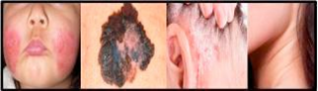

**4.2 Methodology**

In this section, the methodology of the proposed system for detection, extraction and classification of skin diseases images is described. The system will help significantly in the detection of melanoma, Eczema and Psoriasis. The whole architecture can be divided into several modules comprising of pre-processing, feature extraction, and classification. The block diagram of the system is shown in Fig 2.

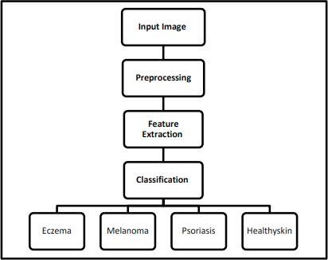

**Fig. 2. The proposed system block diagram.**

**4.3 Pre-processing:**

Achieving high performance of skin disease detection system requires overcoming some major difficulties. Such as creating a database and unifying image dimensions. In the following section, the technique used in image resizing isexplained.

**4.4 Image Resizing:**

To resolve the problem of different image sizes in the database an input image is either increase or decrease in size. Unifying the image size will get the same number of features from all images. Moreover, resizing the image reduces processing time and thus increases system performance. Fig 3 shows the original image of size is 260×325 pixels.

Fig 4 shows the resized image with the new size of 227×227 pixels.

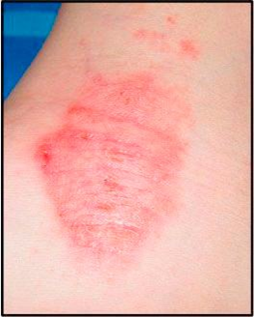

**Fig. 3. Example of Original image of Eczema database**

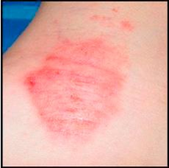

**Fig. 4. Example of resizing image of Eczema database.**

**4.5 Feature Extraction:**

At the beginning, Convolutional Neural Network (CNN) is a set of stacked layers involving both nonlinear and linear processes. These layers are learned in a joint manner. The main building blocks of any CNN model are: convolutional layer, pooling layer, nonlinear Rectified Linear Units (RELU) layer connected to a regular multilayer neural network called fully connected layer, and a loss layer at the backend. CNN has known for its significant performance in applications as the visual tasks and natural language processing [8].

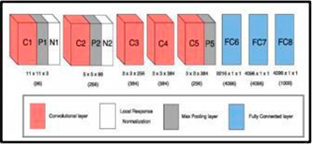

**Fig. 5. Alex Net block diagram [8].**

Alex Net is a deep CNN model, developed by Krizhev sky et al. [8], to model the 2012 ImageNet for the Large-Scale Visual Recognition Challenge (ILSVRC-2012). Alex Net consists of five convolutional layers; where a nonlinear RELU layer is stacked after each convolutional layer. In addition, the first, second, and fifth layers contain max pooling layers, as shown in Figure 5. Moreover, two normalization layers are stacked after the first and the second convolutional layers. Furthermore, two fully connected layers at the top of the model preceded by soft max layer. Alex Net was trained using more than 1.2 million images belonging to 1000 classes [8].

We proposed feature extraction from a pretrained convolutional neural network. Because it is the easiest and robust approach to use the power of pretrained deep learning networks.

**4.6 Classification:**

Classification is a computer vision method. After extracting features, the role of classification is to classy the image via Support Vector Machine (SVM). A SVM can train classifier using extracted features from the training set [9].

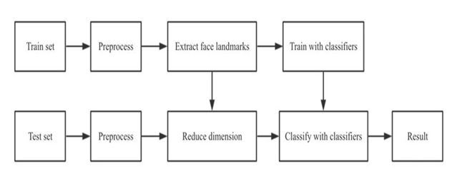

**5. FLOW CHART**

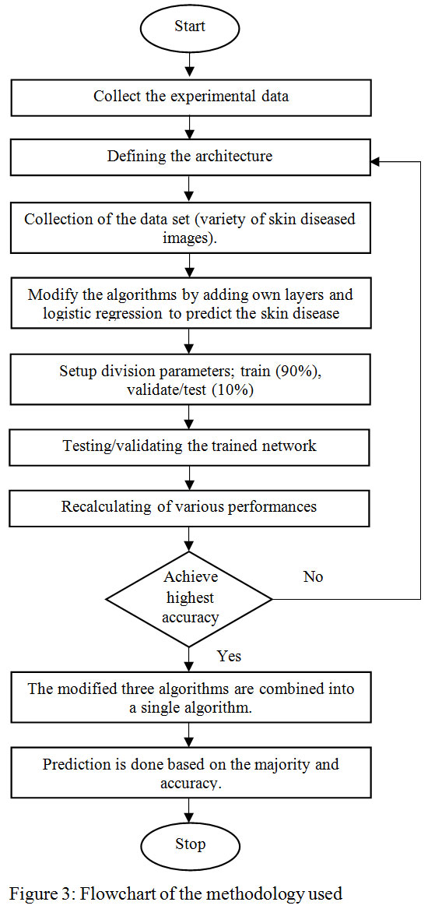

**6. RESULT**

The system is implemented in MATLAB 2018b. We used a platform of Intel Core i3 processor 2.10 GHz with 4- GB RAM.

The Implementation results are shown in Figure 6. Initially, the input images are pre-processed, then features are extracted using pretrained CNN. Finally, classification is performed using SVM classifier.

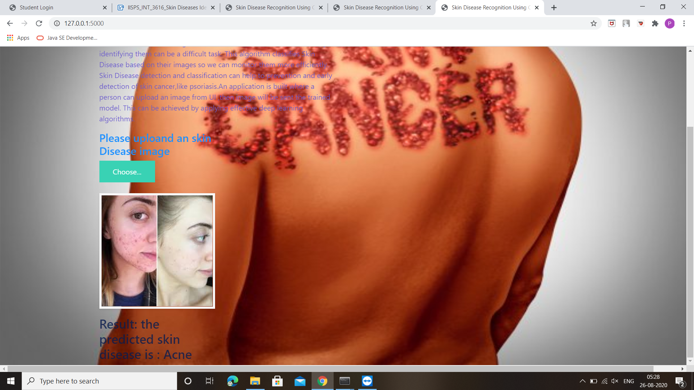

In this study, 100 skin images were used by several dermatological disease patients, also were taken from the Internet. The proposed system can successfully detect 3 different skin diseases with an accuracy of 100%.

We have used 20 of images for validation purpose and 80 images for training purpose. The system works well.

The detection rate of our system is 100%. In the Table 5.1 we can see different detection rate for 3 different diseases.

The detection rate of diseases is very high 100%.

**Advantages:**

* Acute prediction of diseases available first on hand to every citizen who uses this application,
* Disease Analysis possible right from home, sparing the need to visit Hospitals Nursing homes or health centres.
* Statistics on intensity, severity of the disease, past records and present records of others affected by similar disease presented in user interactive formats.
* The system also makes use of geo-location access, through which it becomes easy to identify whether a particular disease has become epidemic with respect to that particular location Awareness, Suggestions and first aid tips for every disease for quick user reference.
* Diseases, when identified quicker can be averted or cured much easier. Eases the jobs for Government Healthcare bodies, Corporation Health officials etc.

**Disadvantages:**

* Needs more than a single image for the prediction.
* They use to need a lot of training data.
* Need to upload new skin diseases datasets frequently

**8. APPLICATIONS**

* It is used by the people having busy schedule and cannot visit hospital at starting period of skin disease.
* It is used by the people to pre-confirm the type of diseases.
* As it reduces the cost, if a person has any money problem these can manage by this.
* If a person unable to consult doctor or come out of house (like covid-19)

**9.** **CONCLUSION**

Detection of skin diseases is a very important step to reduce death rates, disease transmission and the development of the skin disease. Clinical procedures to detect skin diseases are very expensive and time-consuming. Image processing techniques help to build automated screening system for dermatology at an initial stage. The extraction of features plays a key role in helping to classify skin diseases.

In this research the method of detection was designed by using pretrained convolutional neural network (Alex Net) and SVM. In conclusion, we must not forget that this research has an effective role in the detection of skin diseases in Saudi Arabia because it has a very hot weather for the presence of deserts; this indicates that skin diseases are widespread. This research supports medical efficiency in Saudi Arabia.

**10. FUTURESCOPE**

Jason Fried says, “When is your product or service finished? When should you put it out on the market? When is it safe to let people have it? Probably a lot sooner than you are comfortable with. Once your product does what it needs to do, get it out there [10].

Just because you have still got a list of things to do does not mean it is not done. Do not hold everything else up because of a few leftovers. You can do them later. And doing them later may mean doing them better, too. [10]. There are many enhancements and extensions which will be added in the future, first, the method of detect skin disease must be on the mobile application developed, then detection the skin lesion in Dermis layer of the skin, finally must detect all the skin disease in the world and degree of disease.

**11.BIBLIOGRAPHY**

* Arifin, S., Kibria, G., Firoze, A., Amini, A., & Yan, H. (2012) “Dermatological Disease Diagnosis UsingColor-Skin Images.” Xian:
* *International Conference on Machine Learning and Cybernetics*.
* Yasir,R.,Rahman, A.,&Ahmed, N.(2014)“Dermatological Disease Detection using Image Processing and Artificial Neural Network.
* “Dhaka*: International Conference on Electrical and Computer Engineering*.
* Santy, A., & Joseph, R. (2015) “Segmentation Methods for Computer Aided Melanoma Detection.” *Global Conference on Communication Technologies.*
* Zeljkovic, V., Druzgalski, C., Bojic-Minic, S., Tameze, C., & Mayorga, P. (2015) “ Supplemental Melanoma Diagnosis for Darker Skin Complexion Gradients.” *Pan American Health Care Exchanges*
* Suganya R. (2016) “An Automated Computer Aided Diagnosis of Skin Lesions Detection and Classification for Dermoscopy Images.”
* *International Conference on Recent Trends in Information Technology*.
* Alarm, N., Munia, T., Tavakolian, K., Vasefi, V., MacKinnon, N., & Fazel-Rezai, R. (2016) “Automatic Detection and Severity
* Measurement of Eczema Using Image Processing.” *IEEE*.
* Kumar,V.,Kumar, S.,&Saboo,V.(2016)“DermatologicalDiseaseDetectionUsingImageProcessingandMachineLearning.”*IEEE*.
* Krizhevsky, A., ILYA, S., & Geoffrey, E. (2012) “ImageNet Classification with Deep Convolutional Neural Networks.” *Advances in Neural Information Processing Systems.*

**12. APPENDIX**

### HTML:

<html lang="en">

<head>

<meta charset="UTF-8">

<meta name="viewport" content="width=device-width, initial-scale=1.0">

<meta http-equiv="X-UA-Compatible" content="ie=edge">

<title>Skin Disease Recognition Using CNN</title>

<link href="https://cdn.bootcss.com/bootstrap/4.0.0/css/bootstrap.min.css" rel="stylesheet">

<script src="https://cdn.bootcss.com/popper.js/1.12.9/umd/popper.min.js"></script>

<script src="https://cdn.bootcss.com/jquery/3.3.1/jquery.min.js"></script>

<script src="https://cdn.bootcss.com/bootstrap/4.0.0/js/bootstrap.min.js"></script>

<link href="{{ url_for('static', filename='css/main.css') }}" rel="stylesheet">

<style>

.bg-dark {

background-color: #42678c!important;

}

#result {

color: #0a1c4ed1;

}

</style>

<body style = "background-image: url('https://st2.depositphotos.com/1229718/10038/i/450/depositphotos_100383900-stock-photo-skin-cancer-melanoma.jpg'); background-size: 100% 100%;">

</head>

<body>

<nav class="navbar navbar-dark bg-dark">

<div class="container">

<a class="navbar-brand" href="#">Skin Disease Recognition Using CNN</a>

</div>

</nav>

<div class="container">

<div id="content" style="margin-top:2em">

<div class="container">

<div class="row">

<div class="col-sm-6 bd" >

<h3>Skin Disease Recogonition </h3>

<br>

<p><font color="white">Efficient and reliable monitoring of Skin Disease in their natural habitat is essential. This project develops an algorithm to detect the Skin Disease in human. Since there are large number of different Skin Disease manually identifying them can be a difficult task. This algorithm classifies Skin Disease based on their images so we can monitor them more efficiently. Skin Disease detection and classification can help to prevent prevention and early detection of skin cancer, psoriasis.An application is built where a person can upload an image from UI ,then image will be sent the trained model. This can be achieved by applying effective deep learning algorithms.</p>

</div>

<div class="col-sm-6">

<div>

<h4>Please uploand an skin Disease image</h4>

<form action = "http://localhost:5000/predict" id="upload-file" method="post" enctype="multipart/form-data">

<label for="imageUpload" class="upload-label">

Choose...

</label>

<input type="file" name="image" id="imageUpload" accept=".png, .jpg, .jpeg">

</form>

<div class="image-section" style="display:none;">

<div class="img-preview">

<div id="imagePreview">

</div>

</div>

<div>

<button type="button" class="btn btn-info btn-lg " id="btn-predict">Click on this to see what skin disease it is!</button>

</div>

</div>

<div class="loader" style="display:none;"></div>

<h3>

<span id="result"> </span>

</h3>

</div>

</div>

</div>

</div>

</div>

</div>

</body>

<footer>

<script src="{{ url_for('static', filename='js/main.js') }}" type="text/javascript"></script>

</footer>

</html>

### APP.PY:

from __future__ import division, print_function

import os

import numpy as np

from keras.preprocessing import image

from keras.models import load_model

import tensorflow as tf

#global graph

#=tf.get_default_graph()

from flask import Flask, request, render_template

from werkzeug.utils import secure_filename

from gevent.pywsgi import WSGIServer

app = Flask(__name__)

model = load_model("E:\miniproject\Skin_Diseases.h5",compile=False)

@app.route('/')

def index():

return render_template('base.html')

@app.route('/predict',methods = ['GET','POST'])

def upload():

if request.method == 'POST':

f = request.files['image']

print("current path")

basepath = os.path.dirname(__file__)

print("current path", basepath)

filepath = os.path.join(basepath,'uploads',f.filename)

print("upload folder is ", filepath)

f.save(filepath)

img = image.load_img(filepath,target_size = (64,64))

x = image.img_to_array(img)

x = np.expand_dims(x,axis =0)

#with graph.as_default():

preds = model.predict_classes(x)

print("prediction",preds)

index = ['Acne', 'Melanoma', 'Psoriasis', 'Rosacea', 'Vitiligo']

text = "the predicted skin disease is : " + str(index[preds[0]])

return text

if __name__ == '__main__':

app.run(debug = False, threaded = False)

|  |
| --- |
|  |